**Deliverable 1 - DFL**

horizontal line**TASK 1**

A key concern highlighted by groups such as the Midwest Bio-District is that small-scale, sustainable farmers in Ireland are being excluded from large public food contracts because of complex procurement rules. These policies often favor large food suppliers who can meet strict technical and financial requirements, leaving out local producers who use environmentally friendly and community-focused farming methods. This is especially important because public institutions in Ireland, such as schools, hospitals, and government departments, spend billions of euros on food each year. When this spending supports industrial agriculture, it reinforces a food system that is associated with high greenhouse gas emissions, poor labor conditions, and long-distance supply chains that undermine sustainability goals (Department of Agriculture, Food and the Marine, 2021; Teagasc, 2022). Supporting Irish farmers through fairer procurement could help improve national food security, reduce environmental harm, and keep money circulating in rural communities. It could also support Ireland’s goals under the Climate Action Plan and Sustainable Development Goal on responsible consumption and production. While some institutional staff wish to purchase locally or sustainably grown food, they are restricted by outdated rules. Without reform, Ireland’s public spending will continue to bypass those who are best placed to produce healthy, low-impact food for the country.

**What’s at stake is**,

Market access for local, sustainable farmers:

If procurement policies don’t change, many small and agroecological producers will continue to be shut out of large institutional markets, making it harder for them to stay in business or scale their impact.

Public dollars reinforcing harmful food systems:

Without reform, billions in public food spending will keep flowing to industrial suppliers who often rely on extractive farming practices, low wages, and long, carbon-heavy supply chains.

Food system resilience and regional self-reliance:

Excluding local producers weakens regional food security. If crises disrupt national supply chains, the region won’t have strong local networks to fall back on.

Opportunities for community wealth-building:

Local procurement can generate jobs, keep money circulating in the region, and support cooperatively-owned farms and food businesses. These opportunities are lost when contracts go to large, outside corporations.

Public trust and institutional accountability:

Institutions that want to serve healthier, more culturally relevant, or sustainably grown food are held back by rigid rules. This creates frustration and erodes public confidence in these systems to serve community values.

### 

## 

## TASK 2

**MAP 1 – CONCEPTS AND CONNCETIONS MAP**

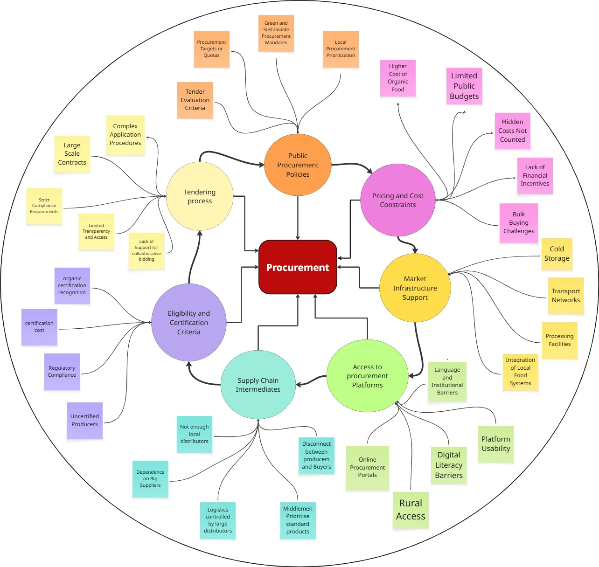

**MAP 2 – ACTION-CONCERN-DEVICES MAP**

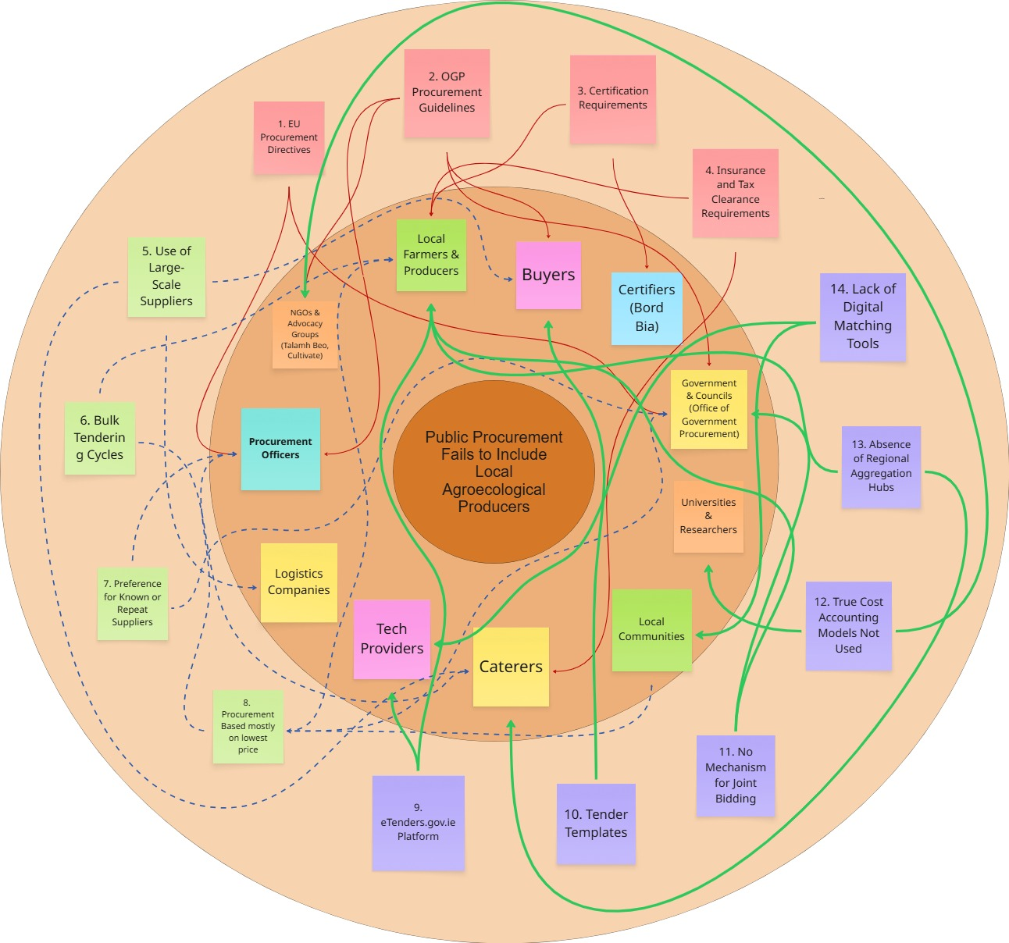

**MAP 3 – NICHE DISCOVERY MAP**

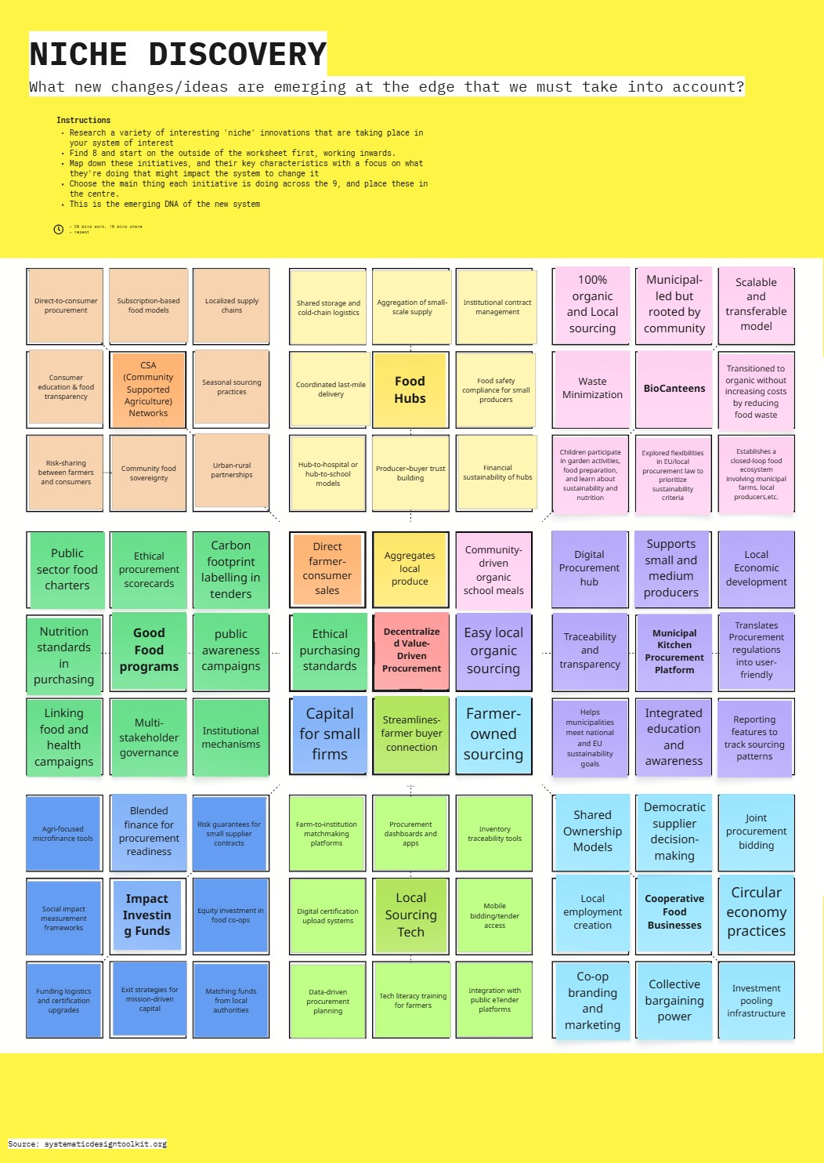

**TASK 3**

1. **Whose perspectives are reflected in the mapping?**

The mapping integrates a rich set of perspectives, and specifically, the perspectives of those who are marginalized within Ireland’s current procurement regime are included:

Small-Scale Organic and Agroecological Producers: The concern features each of these stakeholders. Volume-based tenders, cost-efficiency priorities, with certification barriers reflect their voices. Their concerns are strong. These producers often cannot access public procurement in the Irish Midwest Bio-District since localized, sustainable farming is stressed because strict criteria do not suit their operations like smaller outputs, diversified produce, or seasonal availability.

Local Food Co-ops and Community Food Enterprises: These actors offer support for decentralized food systems. The actor-device map shows that they are under some pressure from within the procurement system. This pressure comes as a result of its preference for more centralized logistics and for large suppliers. Since regional aggregation hubs are absent and policies do not enable them, they cannot involve themselves in public contracts logistically and economically.

Procurement Officers in Public Institutions (e.g., hospitals, schools): Procurement officers, though often seen as gatekeepers, are also bound within routines and rules like OGP guidelines, EU directives, and internal audit requirements. These rules limit their flexibility as well as make them unable to innovate or contract with newer types of suppliers.

Certifiers and Regulatory Agencies (e.g., Bord Bia): Maintaining organic certification standards is key to their role, yet certification can bureaucratically burden small producers or prohibit costs. The maps reflect upon important barriers to market entry. The barriers stem from certification requirements with device-level constraints.

Tech Providers and eTendering Platforms (e.g., eTenders.gov.ie): These online resources often hurt unconnected producers even though meant to ease purchasing. Technological infrastructure can widen access gaps, as revealed in the issue that is platform usability. In rural Ireland, a lack of digital matching tools also reveals this.

Local Communities and Public Sector Caterers: Procurement choices directly affect these actors who often have little say in food sourcing. Even though it is key to driving demand for more ethical and sustainable food, their perspective is often neglected by many.

1. **What is assumed to be stable, and what is negotiable?**

Assumed to be Stable:

Legal Frameworks (EU and National Directives): These incorporate EU Procurement Directives plus Ireland’s OGP Guidelines. Effective methods guide much procurement. They are difficult for one to alter without any meaningful policy overhaul or national-level lobbying.

Tendering Routines (Bulk Tendering Cycles, Lowest Price Bias): These practices stand institutionalized. Schools plus hospitals often rely upon yearly contracts that demand bulk, stable supply. Small organic producers battle against meeting these conditions.

Certification and Regulatory Procedures: Standards for organic labeling imply that actors can comply, embed, and also present producer compliance documentation (such as tax clearance, insurance policies, with regulatory filings) as fixed even when they disproportionately affect the smaller actors.

Negotiable or Changeable Elements:

Procurement Tools and Templates: Platforms such as eTenders may be redesigned so as to include value-based scoring and also regional filters. Tools of procurement may have processes that are simple for tenders with low volume. “Tender templates” are flexible, mutable.

Aggregation and Logistics Models: Reforms that are feasible include the creation of regional aggregation hubs or co-op distribution centers and also shared cold storage facilities. Solutions are widely recognized though not yet institutionalized.

Digital Literacy and Platform Access: Rural producers can be integrated into the procurement system if digital literacy training, mobile bidding options, and also support services are targeted to be provided for them.

Policy Framing and Tender Evaluation Criteria: Public pressure, pilot programs, along with evidence-based advocacy may influence these: "Policy Framing and Tender Evaluation Criteria"—especially around sustainability metrics plus true cost accounting in procurement.

1. **What aspects are missing or uncertain?**

Consumer Demand Dynamics: The maps center on procurement and insufficiently represent demand side actors like parents of schoolchildren, patients in hospitals, or residents in care homes. For demanding of more ethical food systems, these groups should be powerful allies.

Political Will and Implementation Capacity: Policies such as Ireland’s Green Public Procurement Strategy (2024–2027) exist, but people implement them unevenly. It is difficult to ascertain whether procurement officers are trained also empowered. Ascertaining if they are motivated to use these tools also is difficult.

Intra-Government Alignment: It is unclear as to just how state departments differ such as the Department of Health compared with Department of Agriculture vs. Procurement priorities are set either by OGP coordination or by conflict.

Economic Modeling: The maps do not thoroughly tackle systemic change's economic viability like cost comparisons linking centralized versus. True cost accounting fully used would frame localized procurement. Accounting of true cost fully would ensure of this the framing.

1. **What surprised you during the mapping process?**

a. Central Role of 'Devices' in Shaping Market Access (Map 1): In Map 1, the devices emerged as surprisingly powerful actors such as volume thresholds, food safety certifications, procurement scoring templates, and tendering platforms (eTenders.gov.ie). We usually center on human stakeholders such as farmers or buyers. However, the map showed bureaucratic tools and legal documents exert important agency as non-human actors too.

Surprise Insight: Local organic farmers' exclusion occurs because someone excludes them; it isn’t only that people lack will as awareness but is systemically built into the way procurement is structured technologically and legally. For example, small-scale producers are precluded effectively by automated filters and scoring systems before any human decisions are then made.

b. Institutional Inertia Masks Available Leverage Points (Map 3): Map 3 introduces openings as well as leverage points that remain underused such as EU flexibility clauses, pilot projects, also green procurement policies.

Surprise Insight: Local food systems can already be embedded by us into public procurement via current opportunities like value-based selection criteria, SME framework agreements, or low-threshold contracts. However, these are often unexplored still. Institutional inertia, lack of training, or absence of clear political signals are up for blame.

c. Lack of Visibility of the End-User in All Maps: School children or hospital patients are noticeably absent across all three maps. Local community members also are underrepresented on the maps.

Surprise Insight: Agents within that system are not positioned as being people who then eat that food. Even though they are key for legitimizing sustainable food transitions, their preferences, health needs, and cultural connections to food are not embedded into procurement decision-making. That they are absent shows that consumers are disconnected from what is supposed to be for the public-centered system.

**REFERENCES**

* Department of Agriculture, Food and the Marine. (2021). Agri-Food Strategy to 2030. [April 21: Sustainable Food Systems and Ireland’s 2030 Agri-Food Strategy](https://www.gov.ie/en/department-of-agriculture-food-and-the-marine/publications/april-21-sustainable-food-systems-and-irelands-2030-agri-food-strategy/)
* Teagasc. (2022). Sustainability Report of Irish Agriculture 2022. - [2023 - National Farm Survey - 2022 Sustainability Report - Teagasc | Agriculture and Food Development Authority](https://www.teagasc.ie/publications/2023/national-farm-survey---2022-sustainability-report.php)
* Government of Ireland. (2023). Climate Action Plan 2023.
* <https://www.gov.ie/en/office-of-government-procurement/publications/public-procurement-guidelines-for-goods-and-services/>
* <https://gppcriteria.gov.ie/> - Referred this website to get to know more about the GPP criteria
* Jones, M., & Boulton, P. (2009). A fresh approach to school meals: Organic food and sustainable procurement. Sustain: The Alliance for Better Food and Farming.
* Morgan, K., & Sonnino, R. (2007). Empowering consumers: The creative procurement of school meals in Italy and the UK. International Journal of Consumer Studies, 31(1), 19–25.
* Preuss, L., & Walker, H. (2024). Public procurement and social value: A literature review. Journal of Purchasing and Supply Management, 30(1), 100858.
* Thompson, R., & Borrello, M. (2024). Public food procurement for sustainability: Mapping enablers and barriers in European city-regions. Frontiers in Sustainable Food Systems, 8, 1360033.
* URBACT. (2022). Public procurement for food system transition. URBACT Knowledge Hub.
* CSA Networks – <https://www.ams.usda.gov/sites/default/files/media/CSANewModelsforChangingMarketsb.pdf>
* Food Hubs – <https://www.mdpi.com/2071-1050/8/7/616>
* Biocanteens - <https://urbact.eu/networks/biocanteens>
* Farm-to-Institution Programs – <https://www.farmtoschool.org/resources-main/benefits-of-farm-to-school>